Lab Task Six
Database Systems
Mapping ER-EER Model to Relational Model
Objectives
The objective of this lab is to map an Entity Relationship (ER)/Enhanced Entity Relationship (ER) diagram to a relational schema.

Outcomes
After completing this Lab, students are expected to:
- Be able to map an ER diagram to relational schema.
- Be able to map an EER diagram to relational schema.

Lab Exercises

- Map the following ER schema into a relational schema :
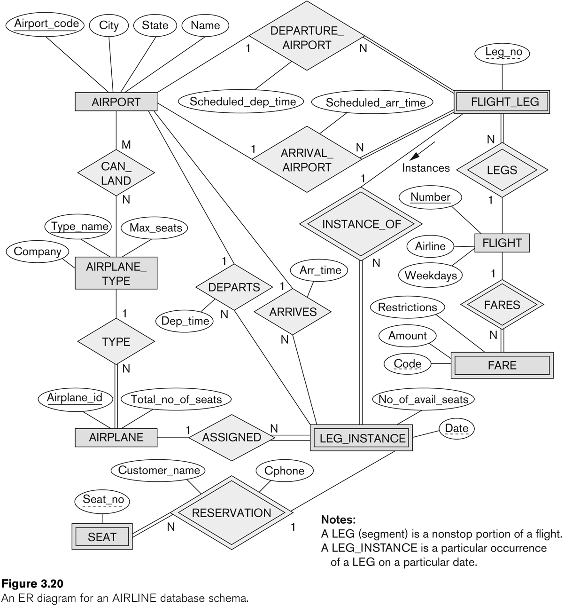

- Map the following EER schema into a relational schema:
